2. Getting Start
2.1 GUI or Command Line?
Although Redhat Enterprise 5.5 provides GUI in which user can operate by moving mouse and clicking, it is strongly recommended that user manages system in command line mode in which you should do everything by typing commands .
Why command line mode? The reason is that Linux acts as server in most time and GUI may affect efficiency and may be not installed in the system

2.2 How to enter command line mode
open terminal in GUI
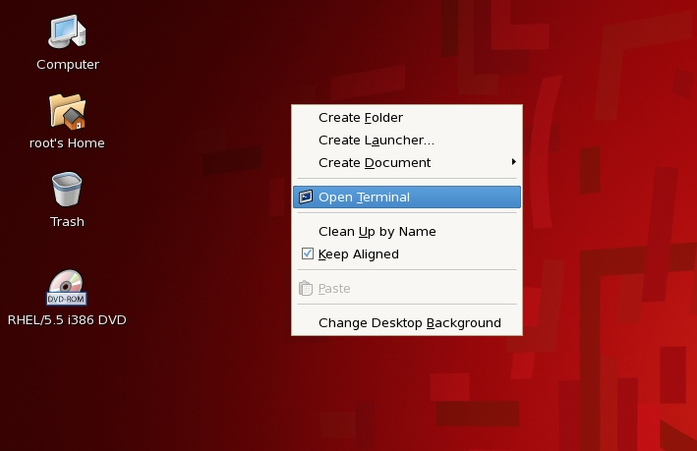
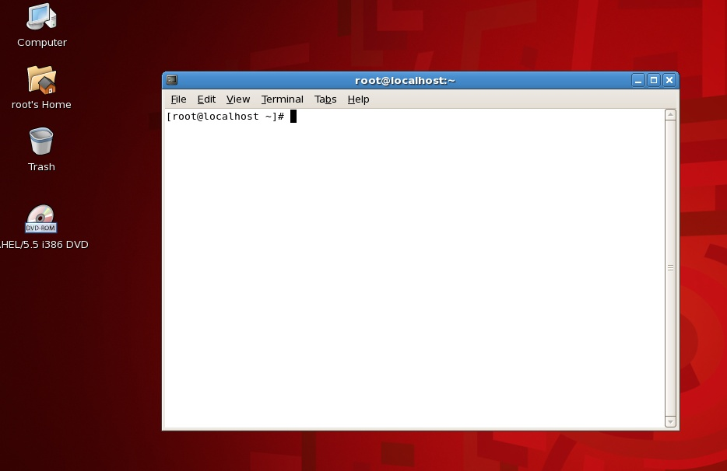
  - three basic commands in linux
    - logout #logout from system
    - reboot #reboot the system
    - shudown –h now #shutdown system immediately
  - How to get help in linux?
- man
command “man” is the powerful help for almost everything linux. For exmple ,if you don’t know how to use command “shutdown” ,you can type “man shutdown”.
#man shutdown
Some commands have multiple man pages. For instance, the passwd command has a man page in section 1 and another in section 5. By default, the man page with the lowest number is shown. If you want to see another section than the default, specify it after the man command:
#man 5 passwd
If you want to see all man pages about a command, one after the other, use the -a to man:
#man -a passwd
This way, when you reach the end of the first man page and press SPACE again, the man page from the next section will be displayed.
- info
In addition to the man pages, you can read the Info pages about a command, using the info command. These usually contain more recent information and are somewhat easier to use. The man pages for some commands refer to the Info pages.
- whatis
A short index of explanations for commands is available using the whatis command, like in the examples below:
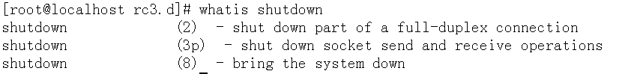
- apropos
If you don't know where to get started and which man page to read, apropos gives more information.
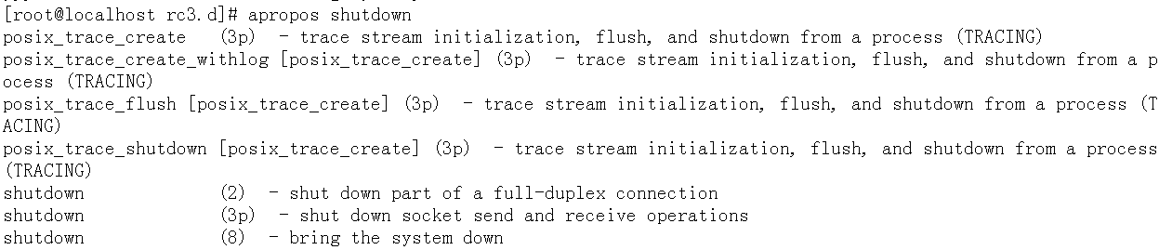
- - - help option
Most commands support the --help, which gives a short explanation about how to use the command and a list of available options. Below is the output of this option with the shutdown command:
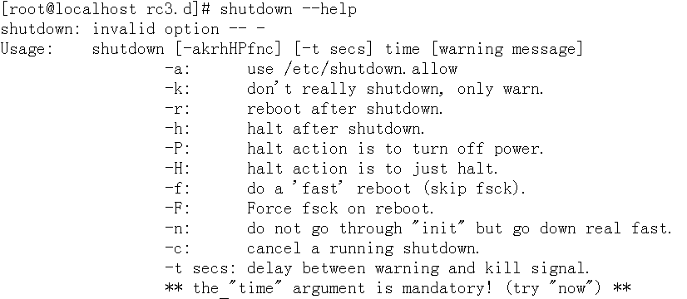
  - Useful site
1.http://www.tldp.org/: The Linux documentation project, all docs, manpages, HOWTOs, FAQs
2. http://www.linuxquestions.org/ LinuxQuestions.org: forum, downloads, docs and much more
3. http://www.google.com : you can search any thing about linux

2.6 Question
What if I forgot root’s password?

